Alright bro, let’s go through this cleanly but without missing any point so you can understand + revise fast for exams. I’ll keep it structured exactly like your chapter.

Major Environmental Issues
The chapter discusses five major environmental problems affecting the planet:
- Ozone Layer Depletion
- Resource Depletion
- Pollution
- Extinction
- Global Warming
Each one has different causes, impacts, and solutions.

1. Ozone Layer Depletion
What is Ozone?
- Ozone (O₃) is a gas present in the stratosphere.
- It protects Earth from harmful ultraviolet (UV) radiation from the Sun.
- It works through the ozone–oxygen cycle:
  - Ozone absorbs UV radiation
  - Converts it into infrared heat
  - This prevents UV rays from reaching Earth.
What is the Ozone Hole?
- The ozone hole is a region (especially over Antarctica) where ozone concentration becomes very low.
- It was caused mainly by CFCs (chlorofluorocarbons) and other ozone-depleting chemicals.
How the Problem Was Solved
- In 1987, countries signed the Montreal Protocol.
- This treaty banned CFCs and other ozone-depleting substances worldwide.
Results
- Atmospheric concentration of these gases has stopped increasing and is now declining.
- Only a few gases like HCFCs are still rising but will be phased out by 2030.
- Small increases in some regions happened due to weak regulations in some East Asian countries, but these are expected to decline.
Future
- Scientists expect the ozone hole to close by ~2040.
Key Lesson
This problem shows global cooperation can solve complex environmental issues.

2. Resource Depletion
Key Concept: Tragedy of the Commons
The Tragedy of the Commons occurs when:
- A shared resource (commons) is used by many individuals.
- Each person tries to maximize personal benefit.
- Eventually the resource becomes overused and degraded, harming everyone.
Examples of Commons
- Grazing land
- Rivers
- Groundwater
- Fisheries
- Air
Example 1: Groundwater in India
- Underground aquifers are shared resources.
- Farmers drill borewells and pump water.
- If some farmers pump excessively:
  - Water level falls
  - Others lose access
- Result → overall groundwater depletion.
Example 2: Overfishing
Fish are renewable only if they reproduce faster than they are caught.
But when fishermen:
- catch fish excessively
- compete with each other
Result:
- Fish population decreases
- Future catch becomes smaller
- Eventually everyone suffers.
Studies show global fish catch is declining, indicating this tragedy.

Can Governments Solve It?
Not always.
Problems:
- Commons may be remote or isolated
- Enforcement difficulty
- Power imbalance (rich farmers influence policing through bribes, caste, power etc.)

Can Privatization Solve It?
Also not guaranteed.
Issues:
- Private owners may focus on profit instead of sustainability
- Might favor powerful people

Local Management Solution
Economist Elinor Ostrom studied real-world commons.
She found:
Local communities can successfully manage shared resources themselves without:
- Government control
- Privatization
For this work she became the first woman to win the Nobel Prize in Economics.

3. Pollution
Pollution is a major environmental problem in India, especially air pollution.
Example: PM2.5 Pollution
PM2.5 = fine particulate matter smaller than 2.5 micrometers.
These particles:
- enter lungs
- damage respiratory system
- cause heart disease.

Comparison: USA vs India
WHO Safety Standard
Safe level ≈ 10 µg/m³

United States
- Uses WHO-like standards.
- Scale on maps:
  - 10 µg/m³ = safe (green)
  - 20 µg/m³ = dangerous
- At 20 µg/m³:
  - health advisories issued
  - people advised to stay indoors.

India
India uses NAAQS (National Ambient Air Quality Standards).
Important fact:
India’s limit is 4× higher than WHO standard.
Even with these relaxed limits:
- Many Indian regions still exceed them.
This means the actual respiratory health risk is very high.

4. Extinction
Species extinction is happening at an extremely fast rate.
Scientists believe we may be entering the Sixth Mass Extinction.
Important fact:
- Species are disappearing faster than we can discover them.
Major causes:
- Habitat destruction
- Climate change
- Pollution
- Overexploitation.

5. Global Warming
Global warming is strongly linked to carbon dioxide (CO₂) levels in the atmosphere.

Charles David Keeling and CO₂ Measurements
Scientist Charles David Keeling made the first precise atmospheric CO₂ measurements.
Why His Work Was Important
Before him:
- CO₂ readings were inconsistent and unreliable.
Measurement Location
He chose Mauna Loa Observatory (Hawaii) because:
- Far from cities
- Ocean winds prevent local pollution effects
- Gives accurate global average CO₂.

Measurements (1957–1960)
He also installed instruments:
- South Pole
- Aircraft at different altitudes
These measurements produced three major discoveries.

Discovery 1: Seasonal CO₂ Variation
CO₂ levels change with seasons.
Reason:
Spring/Summer:
- Trees grow leaves
- absorb CO₂
- CO₂ decreases.
Fall/Winter:
- Leaves fall
- CO₂ released
- CO₂ increases.

Discovery 2: Long-Term Increase
When a trend line is drawn:
CO₂ levels show a steady increase.
Rate of increase matched fossil fuel emissions.

Discovery 3: Missing CO₂
The increase in atmosphere was less than expected.
Conclusion:
Some CO₂ is absorbed by:
- forests
- oceans.

The Keeling Curve
A permanent observatory was later built at Mauna Loa.
The long-term graph is called the Keeling Curve.
Key finding:
CO₂ increased about 100 ppm since 1957.
It is considered one of the most important scientific discoveries of modern times.

Why CO₂ Increase Matters
Current CO₂ level ≈ 413 ppm.
But numbers alone don't mean much without historical context.
Scientists used ice core data to understand past climate.

Ice Core Data
Ice cores are cylinders of ice extracted from permafrost.
How they work:
- Snow traps air bubbles
- Every year a new layer forms
- Each layer preserves ancient atmosphere
By studying bubbles scientists determine:
- past CO₂ levels
- past temperatures.

What Ice Cores Show
They provide 800,000 years of climate history.
Findings:
- Earth experienced 7 ice ages.
- CO₂ and temperature are strongly correlated.
Whenever CO₂ increased → temperature increased.

Why Current CO₂ Is Dangerous
Current CO₂ levels are higher than any time in the past 800,000 years.
And this increase is entirely human caused.
Main sources:
- burning fossil fuels
- deforestation
- industrial emissions.

Acceleration Problem
Even though countries tried to reduce emissions:
CO₂ levels are still increasing rapidly.
This means current policies are insufficient.

Evidence of Global Warming
Scientists observe multiple signs:
1. Shrinking Ice Sheets
- Greenland losing 286 billion tons of ice/year
- Antarctica losing 127 billion tons/year
2. Declining Arctic Sea Ice
Both thickness and area are decreasing.
3. Extreme Weather
Since 1950:
- More record high temperatures
- Fewer record low temperatures
- Increase in heavy rainfall events.
4. Ocean Acidification
Since the Industrial Revolution:
Ocean acidity increased by 30%.
Reason:
- oceans absorb atmospheric CO₂.
Currently oceans absorb about 2 billion tons CO₂ per year.

Predicting Future Climate
Earth’s climate is a non-linear dynamical system.
Meaning:
- small changes can produce unpredictable effects.
Different climate models predict different outcomes.

Temperature Rise Predictions (2100)
Models predict warming between:
1.5°C → 6°C
Implications:
1.5°C
- manageable sea level rise.
6°C
- catastrophic:
- coastal cities flooded
- islands submerged
- major climate disruption.

Paris Climate Agreement (COP21)
Signed in 2015.
Goal:
- keep global warming below 2°C
- ideally below 1.5°C.

Current Reality
Even with existing policies:
Expected warming ≈ 4°C.
New policies might reduce it to:
2.5–2.7°C
But still not enough to reach Paris goals.

Final Big Picture
Environmental Issue | Current Status
Ozone Depletion | Successfully controlled via Montreal Protocol
Resource Depletion | Ongoing problem due to tragedy of commons
Pollution | Severe in countries like India
Extinction | Sixth mass extinction likely underway
Global Warming | Most serious long-term environmental threat

If you want, I can also give you a super-short 2-page exam revision version of this chapter (the kind you can memorize in 10 minutes before the exam). That one is deadly for scoring marks.
Alright Saksham, let’s unpack this step-by-step in a way that’s easy to revise but still keeps every concept. This chapter is basically about the conflict between economic development and environmental sustainability, and why simple GDP growth doesn’t automatically solve environmental problems.

Sustainable Development – Introduction
Definition
The most widely accepted definition comes from the 1987 World Commission on Environment and Development (WCED) report:
“Development that meets the needs of the present without compromising the ability of future generations to meet their own needs.”
This definition emphasizes two goals at the same time:
- Improving the quality of life today
- Preserving resources and environment for the future.
To understand this idea properly, we need to understand two terms separately:
- Development
- Sustainability
Then we see whether they actually fit together.

What is Development?
In modern economics, development is mainly measured using GDP (Gross Domestic Product).
GDP
GDP measures:
- The total value of goods and services produced in a country.
Countries are classified based on GDP:
Type of Country | GDP
Developed countries | High GDP
Developing countries | Medium GDP
Less developed countries | Low GDP
So in economic thinking:
More development = Higher GDP

The Problem with GDP
GDP increases when production increases.
But production requires:
- raw materials
- energy
- land
- water
- minerals
All of these come from natural resources.
So essentially:
Higher GDP → Higher resource consumption
This creates a conflict.

Conflict Between Growth and Sustainability
For development to continue:
- GDP must keep growing every year
This is called sustainable economic growth.
But environmental sustainability requires:
- not exhausting natural resources
- especially non-renewable resources (coal, oil, minerals).
So there is a contradiction:
Economic View | Environmental View
Continuous GDP growth | Limited resource use
More production | Resource conservation
Therefore:
Sustainable GDP growth ≠ Environmental sustainability
Because GDP growth usually means more resource consumption.

Environmental Kuznets Curve (EKC)
To understand this conflict better, economists developed the Environmental Kuznets Curve.
First we need to understand the work of Simon Kuznets.

Simon Kuznets
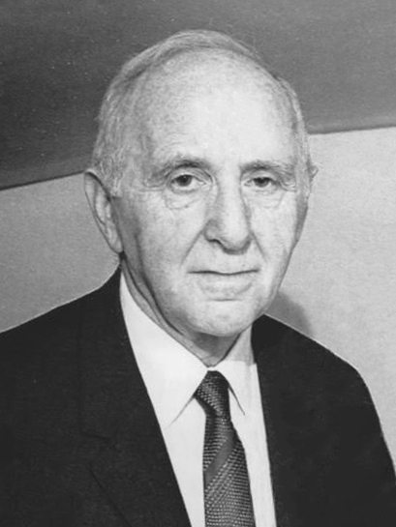
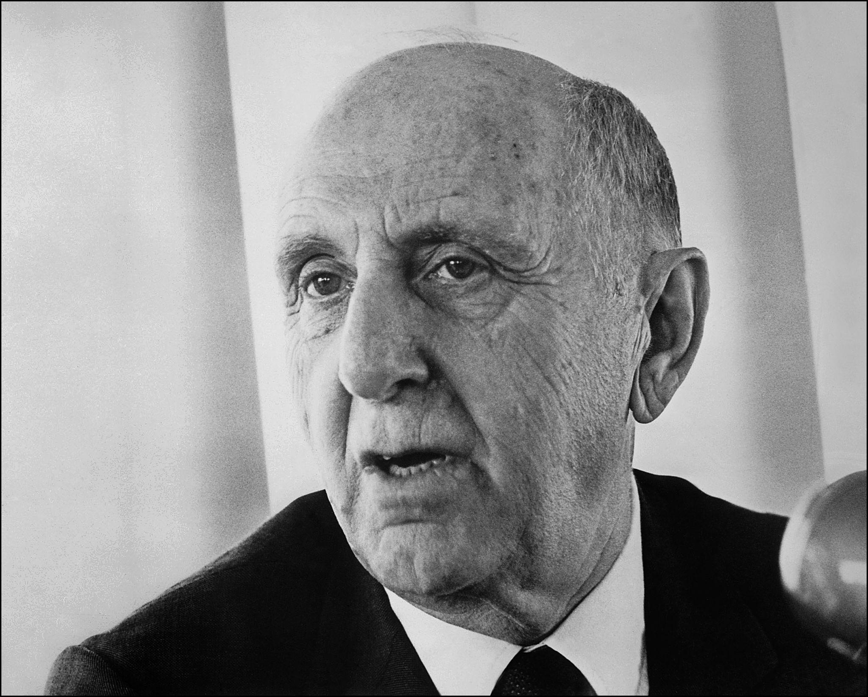


Simon Kuznets was an economist who:
- introduced GDP as a measure of economic development
- collected the first reliable economic data for the USA and Europe.
Before his work:
- economic growth was measured vaguely
- governments had poor data for policymaking.
This lack of understanding contributed to problems like the Great Depression of 1929.
His work helped economists understand year-to-year economic growth.

Kuznets Curve (Income Inequality)
While studying economic data, Kuznets observed a pattern.
He noticed that:
- As income per capita increases, income inequality also increases.
- But only up to a certain point.
- After that point, further economic growth reduces inequality.
This creates an inverted U-shaped curve.
Meaning
Early development stage:
- Industry grows
- Wealth concentrates
- Inequality rises
Later stage:
- Better institutions
- Welfare policies
- Higher education
- Better redistribution
So inequality starts falling.
Kuznets himself warned that this was:
“Perilously close to pure guesswork”
because the data available to him was limited.
But the idea became extremely popular.

Policy Implication for Developing Countries
The logic policymakers used was:
If GDP keeps increasing:
- Inequality will increase temporarily
- Eventually it will automatically decrease
So governments believed:
Just focus on GDP growth and inequality will solve itself.
Example:
Country | Position on Curve
Western Europe | Right side (rich, lower inequality)
India | Near top-left (developing, higher inequality)
At first glance this explanation seems logical.

Environmental Kuznets Curve (EKC)
Later, economists applied the same idea to environmental pollution.
The idea:
- In early development:
  - Industries grow
  - Pollution increases
  - Environment gets damaged
- After countries become rich:
  - People demand clean air and water
  - Governments create environmental laws
  - Pollution decreases
So the curve looks like:
Environmental damage rises first → then falls.
This is called the Environmental Kuznets Curve.

Why EKC Appears to Work
If we compare countries:
Country | Environmental Condition
Europe | Cleaner environment
India | Moderate pollution
Poorer countries | Severe environmental damage
So policymakers believed:
Economic growth alone will eventually solve environmental problems.

The Major Problem With EKC
This conclusion is misleading.
Let’s take the example of Europe.
Europe has:
- strict environmental regulations
- clean cities
- strict pollution control laws
But does Europe actually produce less pollution globally?
No.
Europe still has very high per-capita carbon emissions.
So how does it appear clean?
Because Europe often outsources pollution.

Pollution Outsourcing
Instead of producing goods locally:
Europe imports products from countries like:
- China
- India
- Southeast Asia
These countries perform:
- manufacturing
- mining
- heavy industry
These activities create pollution in those countries, not Europe.
So Europe appears environmentally clean because it has shifted pollution elsewhere.

Why EKC Fails Globally
EKC works only when looking at countries individually.
But when looking at the whole planet, the pollution still exists.
Example:
Country | Pollution Source
Europe | Consumption
India/China | Production
So the planet still suffers environmental damage.
This means EKC does not reduce global environmental degradation.

The Core Conclusion
The Environmental Kuznets Curve suggests:
Economic growth will automatically solve environmental problems.
But in reality:
- Pollution is shifted geographically, not eliminated.
- Global environmental damage continues to grow.
Therefore:
GDP growth alone cannot create sustainable development.

Final Key Idea of the Chapter
True sustainable development requires:
- Economic development
- Environmental protection
- Responsible resource use
Simply increasing GDP will not automatically fix inequality or environmental degradation.
Better policies are required.

✅ If you want, I can also give you a super short “5-minute exam answer version” of this chapter (basically the exact points professors expect in a 10-mark question). It makes writing answers way easier.

